**Practical 5 : Implementation of heb rule learning**

**Hebb Rule Learning :** Neurons that fire together, wire together

**Introduction :**

The Hebb Rule, also known as Hebbian Learning, is a fundamental concept in neuroscience and artificial intelligence. It describes how neural connections are strengthened based on the coincidence of neural activity.

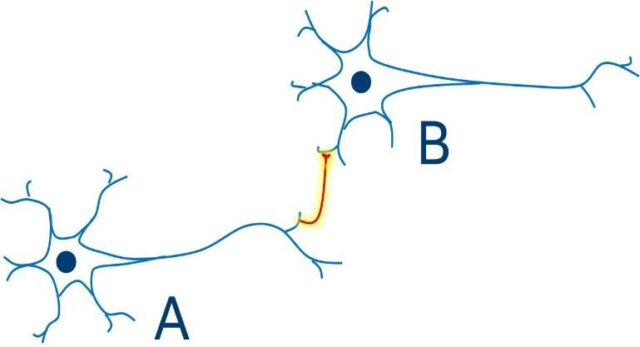

Donald Hebb, a Canadian neuroscientist, first proposed the Hebb Rule in 1949. The rule states that:

"When an axon of cell A is near enough to excite cell B and repeatedly or persistently takes part in firing it, some growth process or metabolic change takes place in one or both cells such that A's efficiency, as one of the cells firing B, is increased."

**Hebb Law :**

1. If 2 neurons on either side are activated Synchronously the weights increases.
2. If 2 neurons on either side are activated Asynchronously the weights decreases .

**Applications :**

* + **Learning and Memory:** The Hebb Rule provides a framework for understanding how learning and memory occur in the brain.
  + **Neural Networks:** The rule is used in artificial neural networks to train models and optimize weights.
  + **Pattern association , Pattern Categorization and Pattern Classification Formula :**

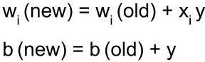

* 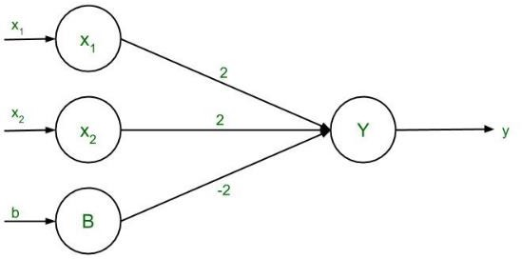**wold : Current weight.**
* **wnew : Updated weight.**
* **x : Input value.**
* **y : Target value (1 or -1).**
* **b : bias**

**Training Algorithm :**

**Step 1 :** Initialize the weights + bias

**Step 2 :** for each Training I/P and O/P pair perform Step 3 and Step 5

**Step 3 :** Set the activation input unit 𝑋𝑖 = 𝑆𝑖

**Step 4 :** Activation output unit y = t

**Step 5 :** Weight and bias updation :

𝑤𝑖 (new) = 𝑤𝑖 (old) + 𝑋𝑖 . y b (new) = b(old) + y

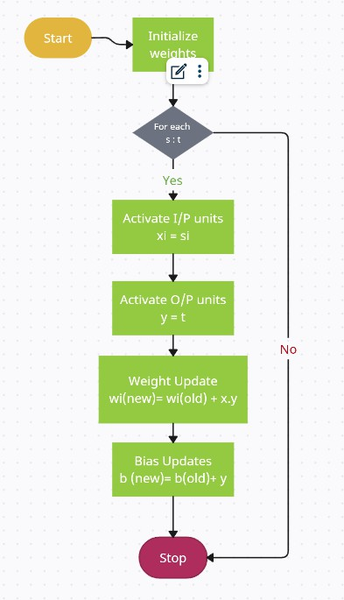

**Question :** Using Hebb rule , find weight required to perform the following classification of given input pattern ‘+’ symbol represent the value is 1 and the empty squares indicates -1 . Consider ‘I’ belongs to the member of the class ( so has the target value 1) and ‘O’ does not belong to the member of class ( so has target value -1)

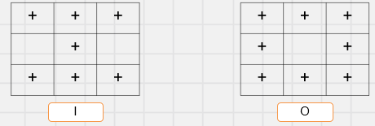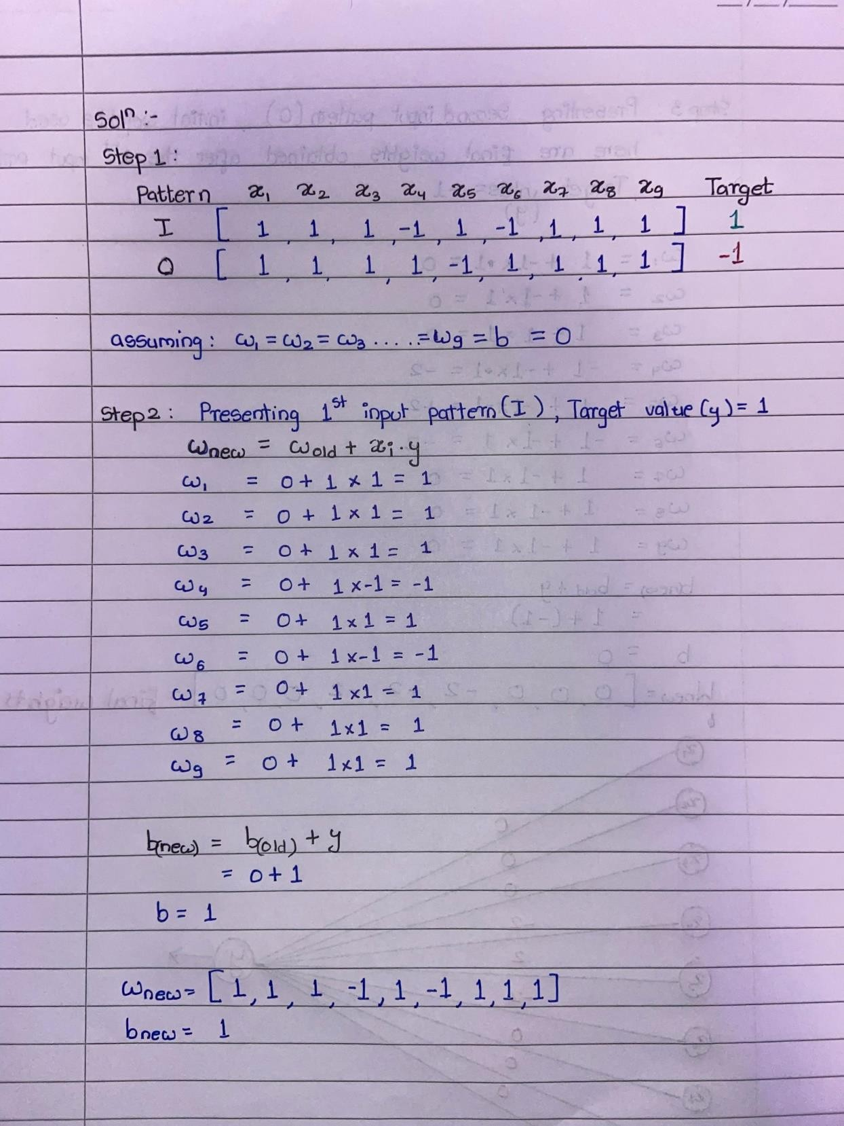

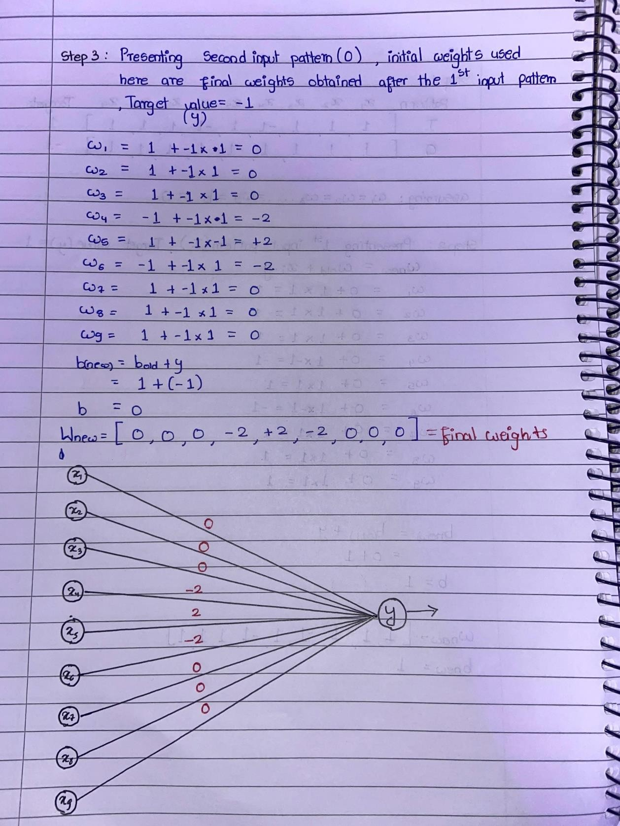

**Code :**

